

IL2237

Laboratory 1 PCB design

# Lab instruction

15 April 2017

## 1 Objectives

The topic of this laboratory is to design an embedded system both hardware and software. We shall build the hardware platforms and demonstrate the sensor signal collection on it.

The laboratory is divided into three parts:

* Design a printed circuit board (PCB) with a micro-controller(MSP430G2533) and a digital sensor (TMP101) and an analog sensor (voltage drop on a variable resistor)
* Complete the soldering of electronic devices on PCB
* Implement the embedded software and show the demo

## 2 Preparation Tasks

*Read the entire laboratory manual in detail before you start with the preparation tasks. Complete the preparation tasks before your lab session in order to be allowed to start the laboratory exercises.*

* It is very important that every student should well-prepared for the lab, reading tutorials carefully before starting laboratory.
* The experimental part of the laboratory (including 3.1.3 Device Soldering and 3.2 Embedded software design) will be conducted by groups of less than 4 students each due to the limited numbers of available PCBs and components as well as debugger tools. However, each student has to develop their own source code and the preparation tasks.
* Course assistants will check if students are well-prepared.
* Whenever you have completed a task of the laboratory, mark the task as completed by putting a cross into the corresponding circle.

### 2.1 Lab environment setup

In order to perform the lab, the designing tools are required to be installed on your computer.

* **Hardware**

For the PCB designing tools, Eagle PCB Design V7.5 is recommended. You can download the proper version form the following links. Some useful tutorials are also available on the website.

Software downloading:

<http://www.cadsoftusa.com/download-eagle/>

Tutorial:

<http://www.cadsoftusa.com/training-service/tutorials/>

Video:

<https://www.youtube.com/user/EAGLECadSoftComputer>

Manuals and books:

<http://www.cadsoftusa.com/training-service/manuals-books/>

* **Software**

Multiples of software development tools are available for MSP430 family devices, such as CCS, IAR and MSP-GCC. In this lab, Code Composer Studio IDE (CCS) is recommended.

[http://www.ti.com/tool/ccstudio?keyMatch=ccs&tisearch=Search-EN-Everything#Technical Documents](http://www.ti.com/tool/ccstudio?keyMatch=ccs&tisearch=Search-EN-Everything%23Technical%20Documents)

2.1 completed

### 2.2 Literature

The following documents, which you can find from the course home pages or from the link below, contains datasheet, reference circuits, user guide and other useful materials. Please read carefully before both hardware and software implementation.

1. <http://www.ti.com/product/msp430g2533?keyMatch=msp430g2533&tisearch=Search-EN-Everything>
2. <http://www.ti.com/product/lm1117?keyMatch=LM1117&tisearch=Search-EN-Everything>
3. <http://www.ti.com/product/tmp101?keyMatch=tmp101&tisearch=Search-EN-Everything>
4. http://www.ti.com/tool/msp-fet?keyMatch=msp%20fet&tisearch=Search-EN-Everything

2.2 completed

## 3 Laboratory Tasks

Designing a sensor based embedded system consists of two phases: *hardware design* and *software design*.

### 3.1 Hardware design

*Your task is to design a printed circuit board (PCB) as shown in Figure 1.*

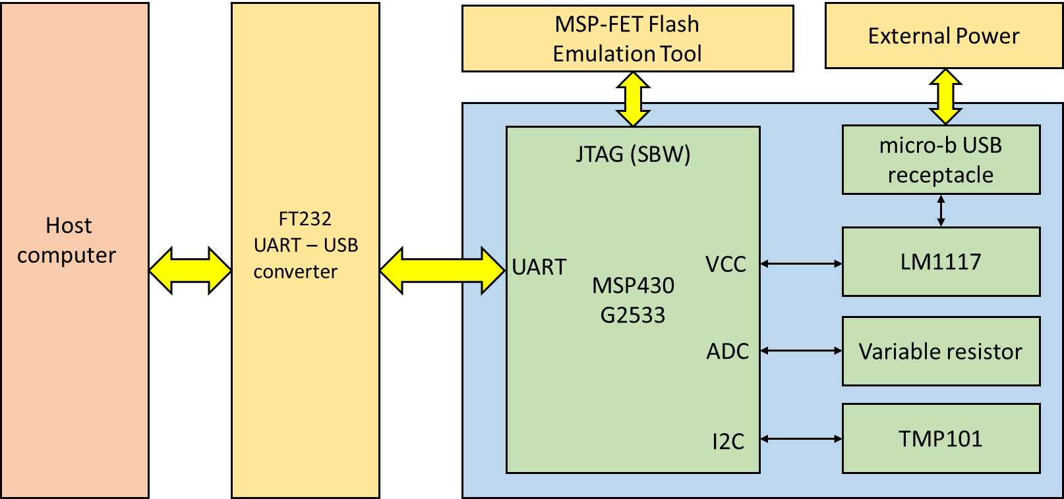

**Figure 1. Block diagram of the system**

Note that ONLY the blue block is needed to be designed. The UART-USB Converter and MSP-FET debugger is provided by the laboratory.

MSP430 Launchpad Development kit is available on TI website. “MSP-EXP430G2 Hardware Design Files” gives a reference project by EAGEL tools, which is very helpful for your own laboratory tasks.

<http://www.ti.com/tool/msp-exp430g2>

#### 3.1.1 Schematic design

In this section you will start to create a schematic according figure 1. EAGLE comes with a lot of library files that contain through-hole and surface mount devices, so you can select proper devices from the library. Besides, you can also add and draw new devices by opening library editor. The possible device package is listed in table 1.

|  |  |  |
| --- | --- | --- |
| **Index** | **Device** | **Package** |
| 1 | LM1117-3.3 | SOT 223 |
| 2 | MSP430G2533IPW20 | TSSOP |
| 3 | TMP101NA/250 | SOT-23 |
| 4 | Pin Header | 2.54mm |
| 5 | Resistor | 0805 |
| 6 | Capacitor | 0805 |
| 7 | LED | 0805 |
| 8 | 10UF Capacitor(for LM1117) | CPOL-EU153CLV-0605 6.3 x 6.3 x 5.3 |
| 9 | Variable Resistor | R-TRIMM64W |
| 10 | Oscillator 12.000MHz | HC-49S |

After completing the schematic, an electrical rule check (ERC) should be performed to check whether there is connection error or not.

Here, please note that the supply voltage used on the board is given by an external power source via a Low-Dropout Linear Regulator LM1117. The external power is either from USB cable or from debugger. TMP101NA/250 is a digitalized temperature sensor with a digital output of SMBus™, Two-Wire, and I2C interface compatibility. A variable resistor is connected as a voltage divider between the supply voltage and the ground. The output voltage from the resistor’s variable terminal (which is the terminal 2 defined in its symbol in library) is used to mimic an analogue sensor with an adjustable output voltage.

3.1.1 Completed

#### 3.1.2 PCB Design

In this section you will create a small PCB design using the Layout Editor. It is recommended that you should connect the MCU pins to the pin header, which is convenient for you software debug. Figure 2 is the layout of a pre-made board, you can take it as a reference.

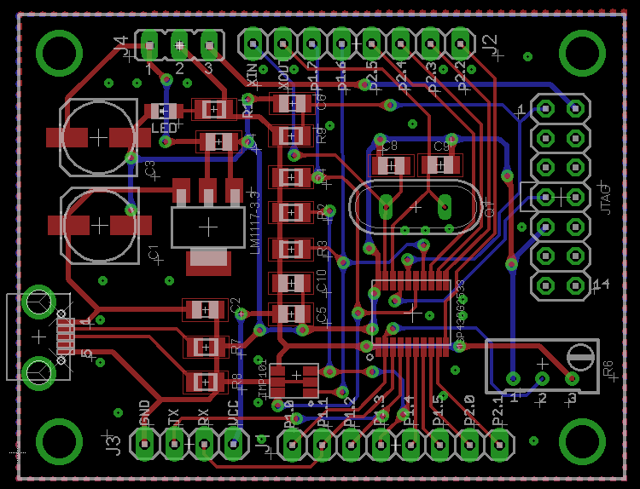

**Figure 2. Reference component placement**

3.1.2 Completed

#### 3.1.3 Device Soldering

Soldering the device onto the pre-made printed circuit board. Note that all of the devices are surface mount device, please be careful during the soldering. You should make sure there is no any short circuit or errors before power up.

There are two method of power supply: from USB cable or from debugger. It is possible to be selected by place a jumper on J4.

|  |  |
| --- | --- |
| **power supply** | **jumper placement** |
| USB | 1-2 |
| Debugger | 2-3 |

3.1.3 Completed

## 3.2 Embedded software design

In this section your task is to implement the embedded software, including I2C bus communication, UART communication, analog signal conversion (ADC) and so on.

### 3.2.1 UART Communication

1. Install a Serial debugging tool such as AccessPort, CommMonitor.
2. Configure USCI A as a UART interface.
3. Test if the MCU is able to transmit and receive data from computer via the UART-USB converter.

3.2.1 Completed

### 3.2.2 ADC

You can measure by a multi-meter the voltage drop between the terminal 2 of the variable resistor, and compare what measured by ADC on MCU. Please adjust the variable resistor to confirm the correlation in-between.

3.2.2 Completed

## 4 Results

In order to pass this laboratory each student must

* have completed the preparation tasks
* have completed the laboratory tasks to show on your computer that the temperature signal does follow the temperature change and the analog signal does follow the manual adjustment of the variable resistor.